**TERMS OF REFERENCE**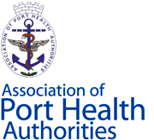

**OPERATIONAL BOARD**

**Aim**

The aim is to create an Operational Board of officials employed in seaports and airports to underpin the technical work of the APHA Executive Board and to encourage engagement between management, political and operational aspects of port health activity in the UK.

**Terms of Reference**

* The Operational Board (OB) will be constituted of 3 officials from each of the APHA technical working groups.
* The OB will elect a Chairperson from its number who will also sit on the APHA Executive Board to provide advice and information.
* The OB will elect a secretary from its number who will liaise with the OB Chairman to plan meeting dates, agendas etc. and liaison with the Executive Board.
* The OB will meet at least three times per year.
* Meetings may be conducted through electronic means, video conferencing, social media etc.
* The OB will lead on the needs assessment of training and development for operational staff in seaports and airports.
* Funding will be provided to the OB by the APHA Executive Board as required.